***NAME: HUZAIFA SHAHID***

***GROUP: ALI HAIDER***

***REPORT #: 03***

***TASK TITLE: LIST TAGS AND TABLE***

CODE:

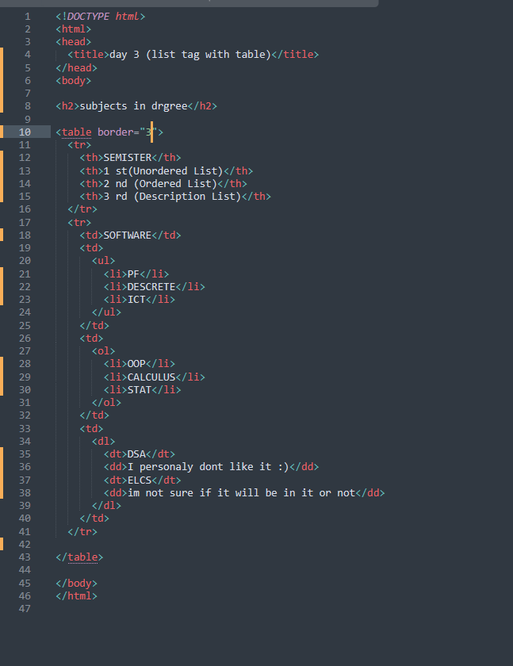

OUTPUT:

